# ST.XAVIER’S COLLEGE

# MAITIGHAR, KATHMANDU



**Computer Graphics**

**Lab Assignment #2**

**Submitted By:**

Pankaj Niroula

013BSCCSIT025

**Submitted To:**

Mr. Anil K. Sah

Lecturer

Department of Computer Science

**Date of Submission : August 7, 2015**

1. **Write a program to make a simple calculator.**

Source Code:

|  |
| --- |
| //---------------------------------------------------------------------------  #include <vcl\vcl.h>  #pragma hdrstop  #include "calc.h"  //---------------------------------------------------------------------------  #pragma package(smart_init)  #pragma resource "*.dfm"  TForm1 *Form1;  int x, y, flag = 0, ch;  //---------------------------------------------------------------------------  __fastcall TForm1::TForm1(TComponent* Owner)  : TForm(Owner)  {  }  int setvalue(int a){  if(!flag){  x = a;  flag = 1;  return x;  }  else{  y = a;  flag = 0;  return y;  }  }  int action(int a){  if(a == 5){  switch (ch)  {  case 1:  {  return(x = x + y);  }  case 2:  {  return (x - y);  }  case 3:  {  return(x = x * y);  }  case 4:  {  return(x = x / y);  }  }  }  if( a == 6){  x = 0;  y = 0;  return 0;  }  return -1;  }  //---------------------------------------------------------------------------  void __fastcall TForm1::Button7Click(TObject *Sender)  {  Edit1->Text = setvalue(7);  }  //---------------------------------------------------------------------------  void __fastcall TForm1::Button0Click(TObject *Sender)  {  Edit1->Text = setvalue(0);  }  //---------------------------------------------------------------------------  void __fastcall TForm1::Button1Click(TObject *Sender)  {  Edit1->Text = setvalue(1);  }  //---------------------------------------------------------------------------  void __fastcall TForm1::Button2Click(TObject *Sender)  {  Edit1->Text = setvalue(2);  }  //---------------------------------------------------------------------------  void __fastcall TForm1::Button3Click(TObject *Sender)  {  Edit1->Text = setvalue(3);  }  //---------------------------------------------------------------------------  void __fastcall TForm1::Button4Click(TObject *Sender)  {  Edit1->Text = setvalue(4);  }  //---------------------------------------------------------------------------  void __fastcall TForm1::Button5Click(TObject *Sender)  {  Edit1->Text = setvalue(5);  }  //---------------------------------------------------------------------------  void __fastcall TForm1::Button6Click(TObject *Sender)  {  Edit1->Text = setvalue(6);  }  //---------------------------------------------------------------------------  void __fastcall TForm1::Button8Click(TObject *Sender)  {  Edit1->Text = setvalue(8);  }  //---------------------------------------------------------------------------  void __fastcall TForm1::Button9Click(TObject *Sender)  {  Edit1->Text = setvalue(9);  }  //---------------------------------------------------------------------------  void __fastcall TForm1::Button10Click(TObject *Sender)  {  ch = 1;  }  //---------------------------------------------------------------------------  void __fastcall TForm1::Button11Click(TObject *Sender)  {  ch = 2;  }  //---------------------------------------------------------------------------  void __fastcall TForm1::Button12Click(TObject *Sender)  {  ch = 3;  }  //---------------------------------------------------------------------------  void __fastcall TForm1::Button13Click(TObject *Sender)  {  ch = 4;  }  //---------------------------------------------------------------------------  void __fastcall TForm1::ButtonEqualClick(TObject *Sender)  {  Edit1->Text = action(5);  }  //---------------------------------------------------------------------------  void __fastcall TForm1::Button14Click(TObject *Sender)  {  Edit1->Text = action(6);  }  //---------------------------------------------------------------------------  void __fastcall TForm1::Label1Click(TObject *Sender)  {  Edit1->Text = "This calculator is limited to only single digit operation.";  }  //-- |

**Output Screen:**

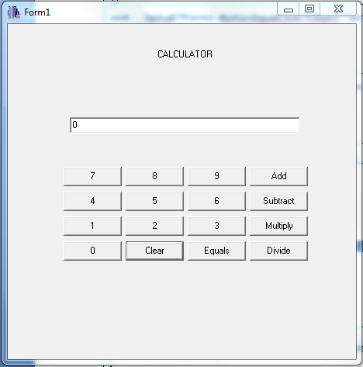

**Conclusion:**

Having used the Borland C++ Builder to build a simple calculator, we can conclude that it can be used to conveniently develop application with graphical user interface.